Nompumelelo Mtshatsheni, Student Number: BXMDLL7W9

ITDA310 – Continuous Assessment Test

May 22, 2020

Question 1

Question 2 – Cursor

My pcs does not want to run all the procedures, I tried even re-installing MySQL and Xampp nothing seems to be working. I am terribly sorry for not being able to produce three screenshots that will indicate all the procedures

Question 3

Question 4

1. Database table

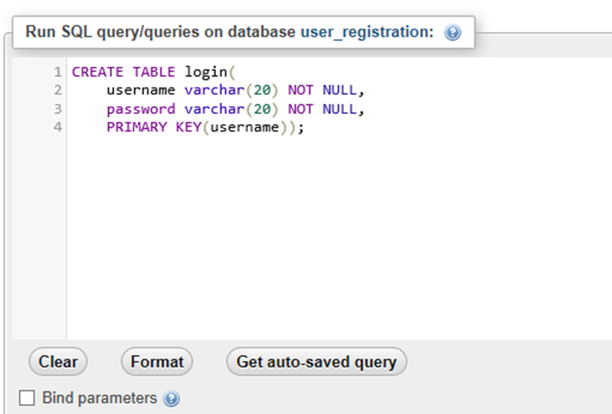

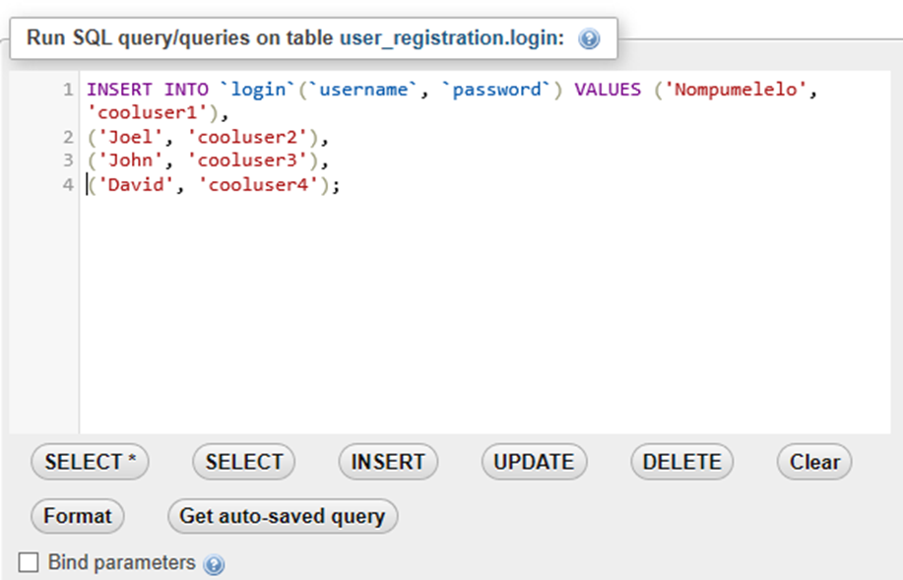

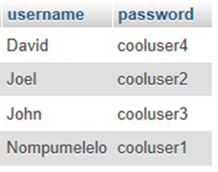

1. Login interface

